Practical no. 2
Name :- Danish Altaf Solkar Enrolment no. :-24111590805
Class :- CO3K – B Subject :- OOP
Aim :- To display the message “Welcome to the world of C++” using manipulators.
Program :-
#include<iostream.h>
#include<conio.h>
void main()
{
clrscr();
cout<<endl<<"Welcome to the World of C++";
getch();
}
OUTPUT:-
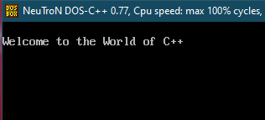

Aim :- Show the use of function outside the class using scope resolution operator.
Program :-
#include<iostream.h>
#include<conio.h>
class Calculator
{
int num1,num2;
public:
void getNumbers();
void displaySum();
};
void Calculator::getNumbers()
{
cout<<"Enter value of no. 1 :- ";
cin>>num1;
cout<<"\nEnter value of no. 2 :- ";
cin>>num2;
}
void Calculator::displaySum()
{
int sum;
sum=num1+num2;
cout<<"\nSum :- "<<sum;
}

void main()
{
Calculator cal;
clrscr();
cal.getNumbers();
cal.displaySum();
getch();
}
OUTPUT:-
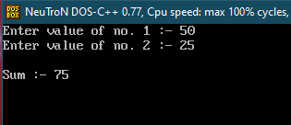

Aim :- To access the global variable using scope resolution operator.
Program :-
#include<iostream.h>
#include<conio.h>
int num=100;
void main()
{
int num=50;
clrscr();
cout<<"Local variable value :- "<<num<<endl;
cout<<"Global variable value :- "<<::num<<endl;
getch();
}
OUTPUT:-
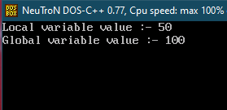

Aim :- Format the following statement using manipulators
(Rate=412345 period=35 year=2024)
Program :-
#include<iostream.h>
#include<conio.h>
void main()
{
clrscr();
cout<<endl<<"Rate=412345\tPeriod=35\tYear=2024";
getch();
}
OUTPUT:-
